**EXPERIMENT NO: 5**

**Aim: Implement and Evaluate Classification Algorithms languages like JAVA/ python/R**

**Import Libraries:**

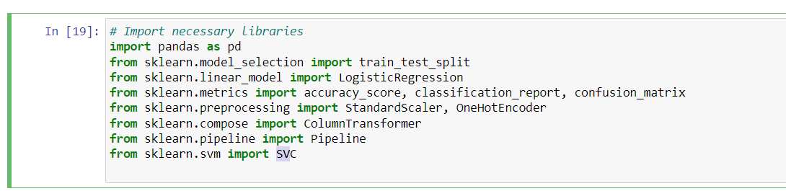

**Load the titanic dataset:**

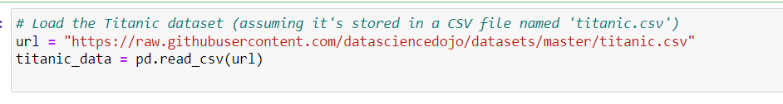

**Display the first few rows of the dataset:**

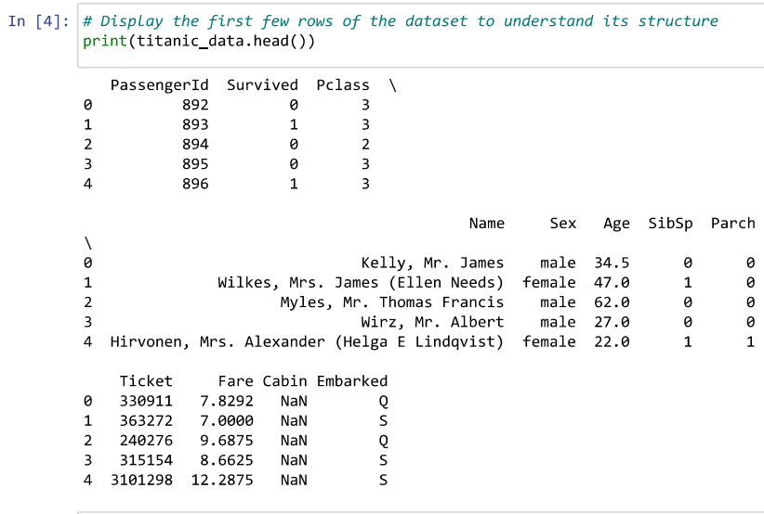

**Data Preprocessing:**

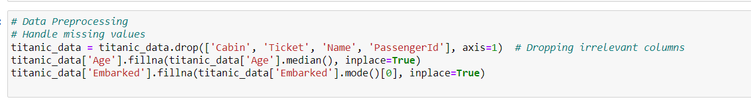

**Encode Categorical Variables:**

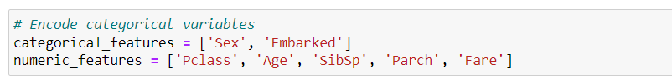

**Create a Column Transformer:**

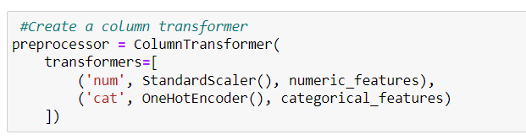

**Define the Model:**

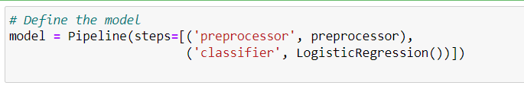

**Train-Test Split:**

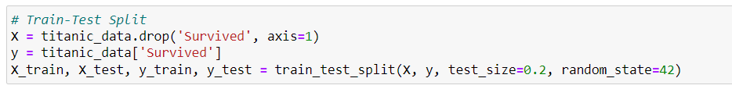

**Model Training**:

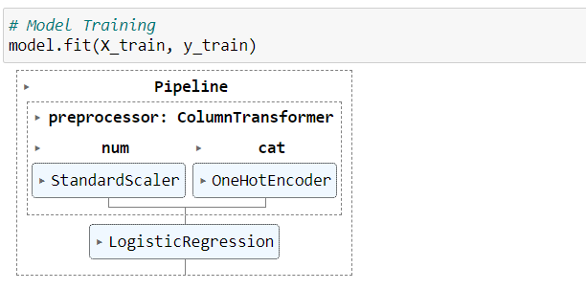

**Model Evaluation:**

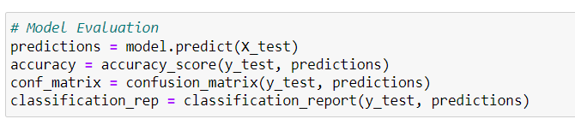

**Display Results:**

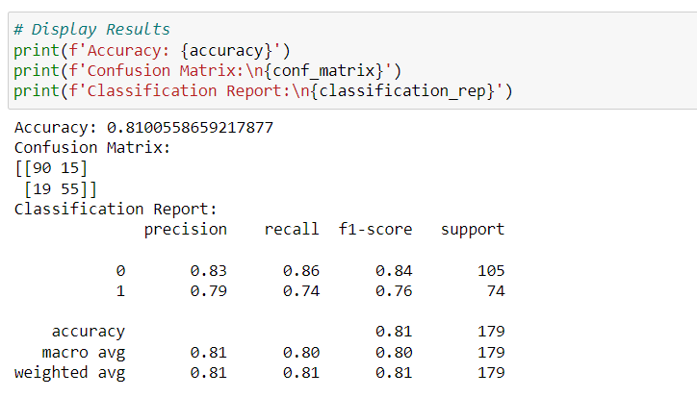

**Import and define Random Forest Model:**

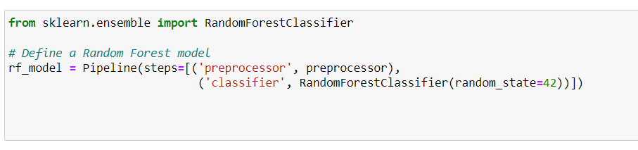

**Train Random Forest Model:**

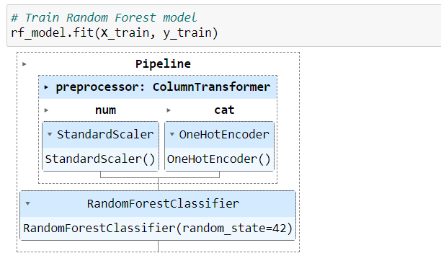

**Evaluate Random Forest model:**

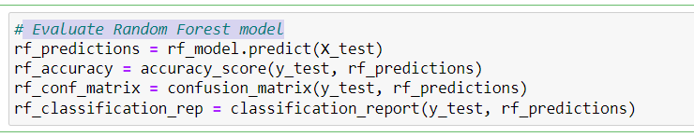

**Display Random Forest Results:**

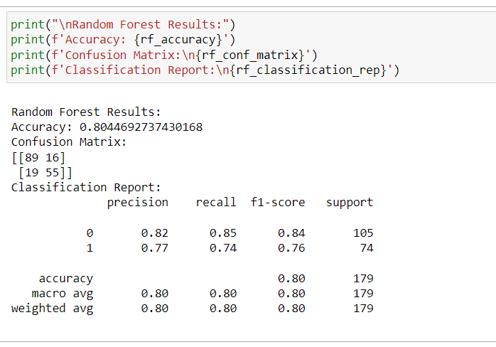

**Define a Support Vector Machine model:**

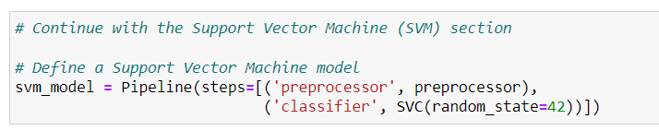

**Train Support Vector Machine model:**

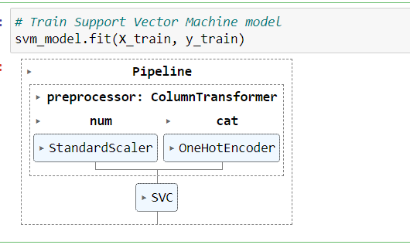

**Evaluate support vector machine model:**

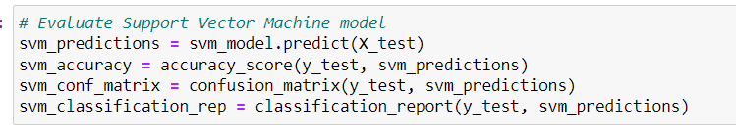

**Display Support Vector Machine Results:**

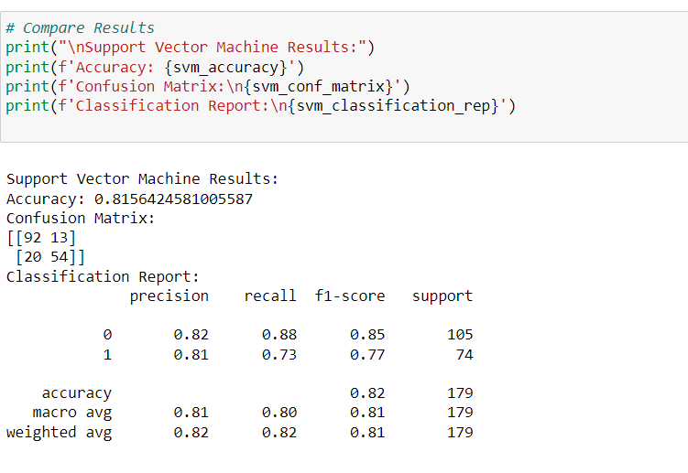

**Identify the best model based on accuracy:**

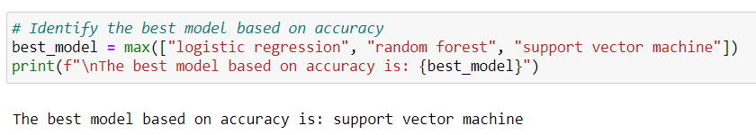

**Conclusion:**

Hence, we have successfully studied to implement and Evaluate Classification Algorithms languages like JAVA/ python/R